ABB

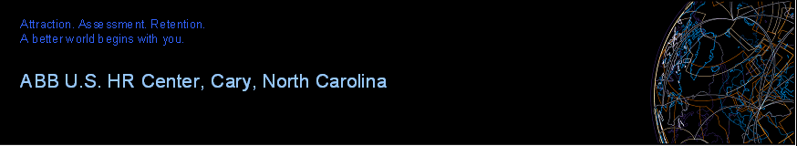Welcomes

Ekrem Kocaguneli

**Interview Schedule**

**Position:** Principal Scientist

**Location:** 940 Main Campus Drive

Raleigh, NC 27606

**Monday, November 26, 2012**

|  |  |
| --- | --- |
| **Time** | **Agenda** |

|  |  |
| --- | --- |
| **8:00am – 8:30am (EST)**  **8:30am – 9:15am**  **9:15am – 10:00am**  **10:00am – 10:45am**  **10:45am – 11:45am**  **11:45am – 1:00pm**  **1:00pm – 1:45pm**  **1:45pm – 2:15pm**  **2:15pm – 2:45pm** | Andy Cordes, ISS Department Manager (location: Andy’s office)  Aldo Dagnino, ISS Software Architecture and Technology Group Manager (location: Aldo’s office)  Eric Harper, Senior Researcher (location: Small Conference Room I)  Lan Lin, Researcher (location: Small Conference Room I)  **Presentation to team members** (location: 5th Floor Board Room)  **Lunch**  David Cox, Senior Researcher  Shakeel Mahate, Senior Researcher (location: Small Conference Room I)  Le Tang, USCRC Director (location: Le’s office)  Kathy Doherty, HR Business Partner (location: Kathy’s office) |

**Who to Contact Upon Arrival:**

Take the elevator to the 2nd floor and from the lobby phone dial extension 3871 for Andy Cordes.